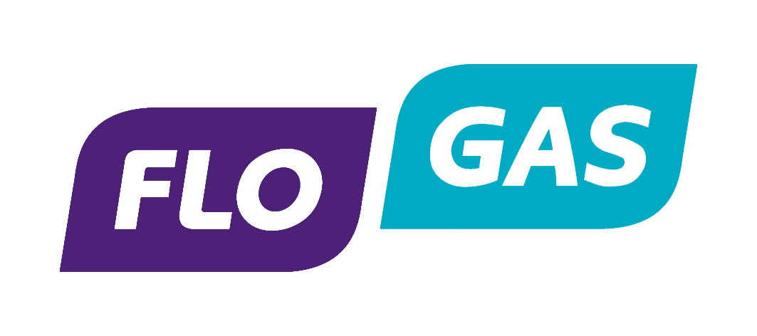

Flogas Britain – Anti Bribery & Corruption Statement

Flogas Britain Limited is committed to conducting its business in an open, honest and ethical manner and the Board, the Managing Director and senior management of the company have a zero risk appetite for and a zero tolerance approach to all forms of bribery and corruption. We expect those with whom we work to also abide by these standards.

Part of our commitment to our values is to adhere strictly to relevant laws in relation to bribery and corruption including the Bribery Act 2010 in the UK where they are relevant to our operations and / or where they set the standards that we consider it is imperative for the company to follow.

Our Anti-Bribery and Corruption policy sets out our approach on the giving and receiving of hospitality and gifts (as well as other areas); and we want to let our business partners you know our approach.

• Our policy sets out various circumstances when gifts or hospitality can be offered or accepted by or to a Flogas employee. The rules do not seek to eliminate normal business courtesies that are reasonable and proportionate.

• This is part of our view that all our activities between us and our business partners should be as open and transparent as possible; and enables us to be confident that there is no risk that any activity could be perceived to be improper or inappropriate.

Where you may kindly offer our employees or others working for us token gifts or business hospitality as part of the cordial relations we have with one another, I hope you will understand that this will only be able to be accepted if these items comply with our policy. If you would like to see a copy of our policy to find out more about our approach, we would be happy to send you a copy.

During the tenure of our working relationship we may want to discuss the anti-corruption procedures that your business has and seek confirmation from you that your organisation has equivalent standards of conduct to those set out in our procedures. We would be grateful for your assistance with these requests.

Similarly, should you contract with a third party on our behalf, we may also require confirmation about the steps you are taking to ensure those other parties have suitable anti- corruption procedures.

Finally, we also encourage our business partners to let us know if at any time they encounter any potentially corrupt behaviour that could affect the work we do together. In these circumstances, please contact Sarah Coop, Head of H.R. or Ivan Trevor, Finance Director, who are responsible for the implementation and monitoring of our anti-corruption policy.
Their contact details can be obtained from our website.

In the meantime, if you have any questions, please feel free to contact us.

